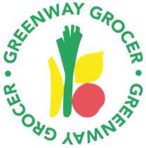

You are warmly invited to

The Crossroads Community Hub
‘OPEN HOUSE’
Friday 15th July 11.30am – 2.30pm
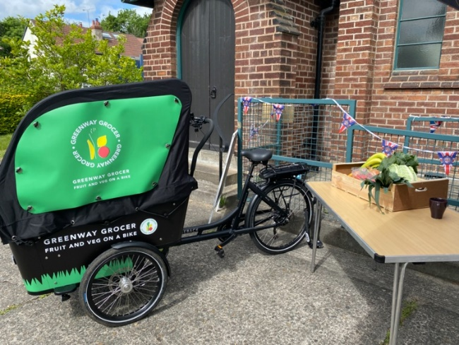

With an update on the Greenway Grocer (12.15pm)

We would love to invite you to drop into The Meeting Place Café at the Crossroads Community Hub on Friday July 15 between 11.30am and 2.30pm. This is an opportunity to hear our latest news on how the project is developing through a short presentation at 12.15pm. A simple sandwich lunch will be provided with refreshments

RSVP by Monday 11 July 2022
cchub@hbc.org.uk

